WORKSHEET
SESSION 2016- 2017
SUBJECT: SCIENCE
CLASS VII
MAX MARKS: 25 TIME: 1 hr

General Instructions:
1 Read the question paper very carefully.
2 Draw neat labelled diagrams wherever required.
3. Read the instructions carefully and select the questions accordingly. You will be provided with a graph paper.
4. Answers to all questions must be written on separate answer scripts provided.
5. Paper consists of 3 printed sides.
PHYSICS

- Choose the correct answer for each of the following. [1/2X2=1]
- Time period of pendulum does not depend on
- Mass of the bob
- Size of the bob
- Length of the string
- All of these
- Mercury level fall easily in a
- Digital thermometer
- Clinical thermometer
- Laboratory thermometer
- None of these

- Use the appropriate term for the sentence given [0.5X4=2]
Thermal equilibrium | vacuum | insulator | odometer
speedometer | conduction | copper | Air
- Conduction of heat does not take place in.
- It is a device used to measure speed of a vehicle.
- Example of an insulator.
- Radiation can travel through :

- Fill in the blanks [0.5X3=1.5]
- Handles of cooking utensils should be made of material that are________.
- Black surface ____ and _________ heat faster.
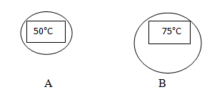
- Copy diagram in your answer sheet and show the direction of flow of heat and give reason for that. [1]

- Answer in brief. [2X2=4]
- Which instruments were used to measure time during ancient times?
- Convert 75°C into °F.

- If an iron rod is heated from one end, you will find its other end is also hot after sometime. [1/2+1]
- Identify the way of transfer of heat in this method.
- Differentiate between Radiation and convection.

- Sam is driving a car, his movement is shown by the given graph
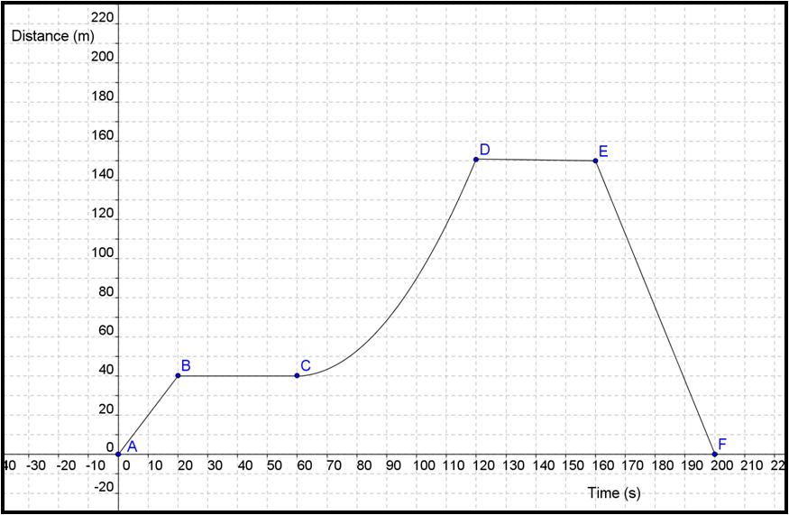

- Briefly explain the type of motion is shown between point C and point D and why? [1]
- What is the difference between the motion shown by the car in part AB and DE? [1½]
- What does point F tells about the car? [1]
- Calculate average speed of the car. [1.5]

- Write about the advantages of conduction in day to day life. [2]
- Differentiate between uniform and non-uniform motion. (2)
- Give examples that show the disadvantages of effect of heat in solids. (3)
- What is the SI unit of displacement? Give an example of displacement (2)

